**CSA1668-DATAWAREHOUSE AND DATA MINING FOR PATTERN ANALYSIS.**

**T.MITHILTUVVARA**

**192125050**

**1.PLOTING GRAPHS USING R PROGRAMING ?**

**-> BOXPLOT**

**-> PIE CHART**

**-> HISTOGRAM**

**-> BARGRAPH**

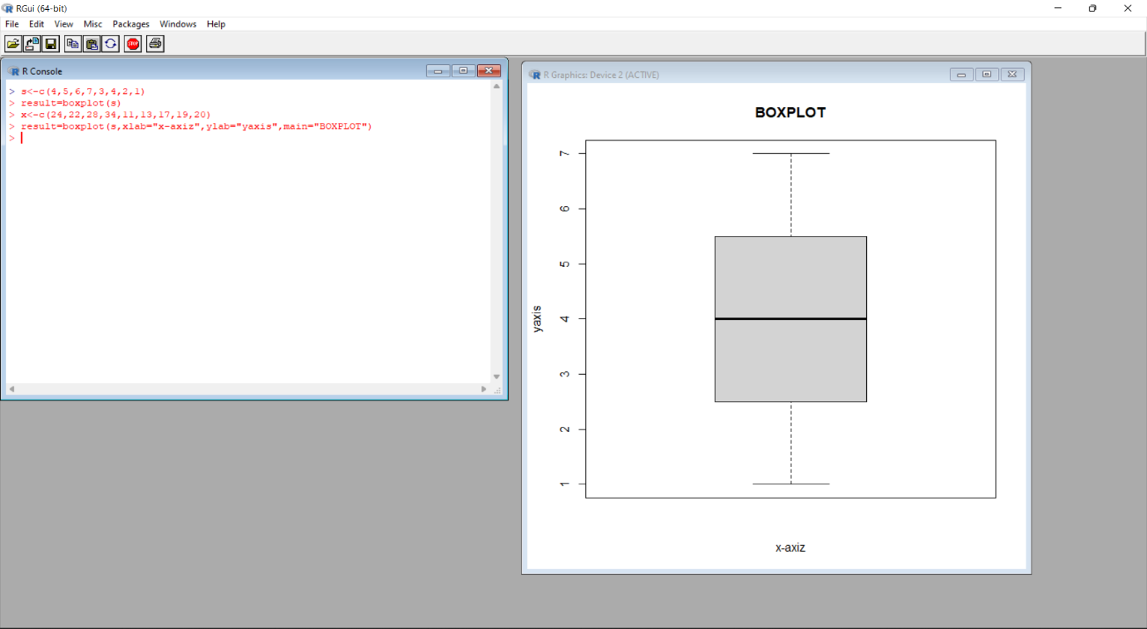**BOXPLOT.**

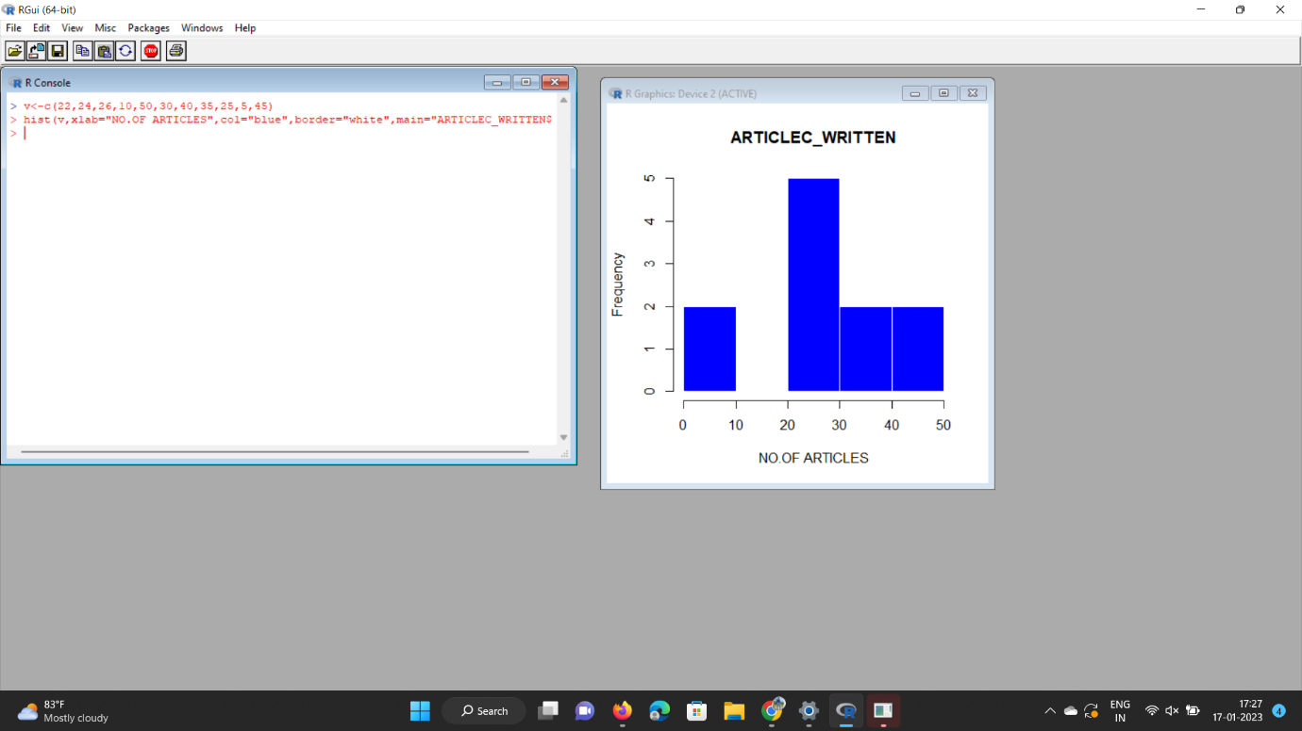**HISTOGRAM.**

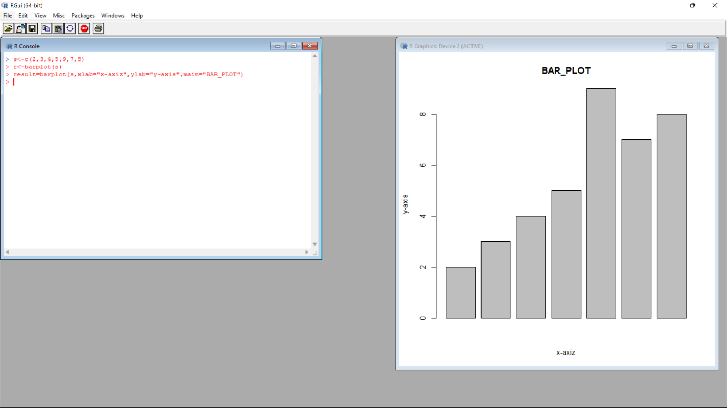**BAR GRAPH.**

**PIE CHART.**

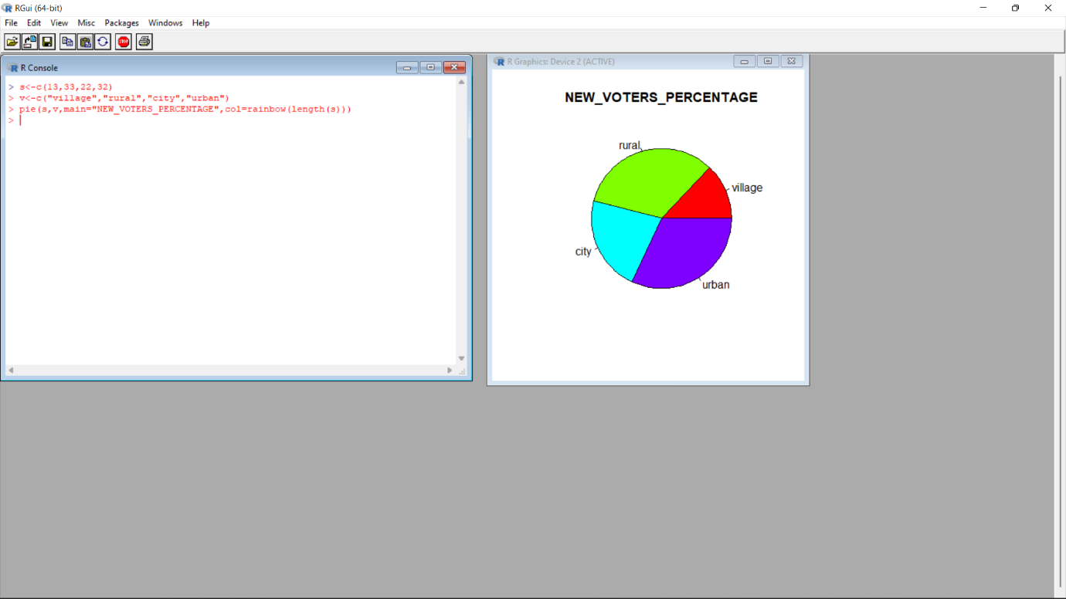

**6.REGRESSION ANALYSIS USING R TOOL ?.**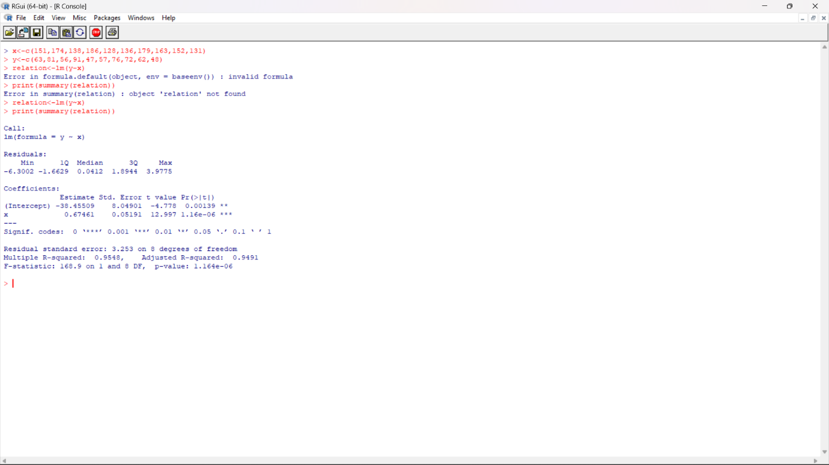

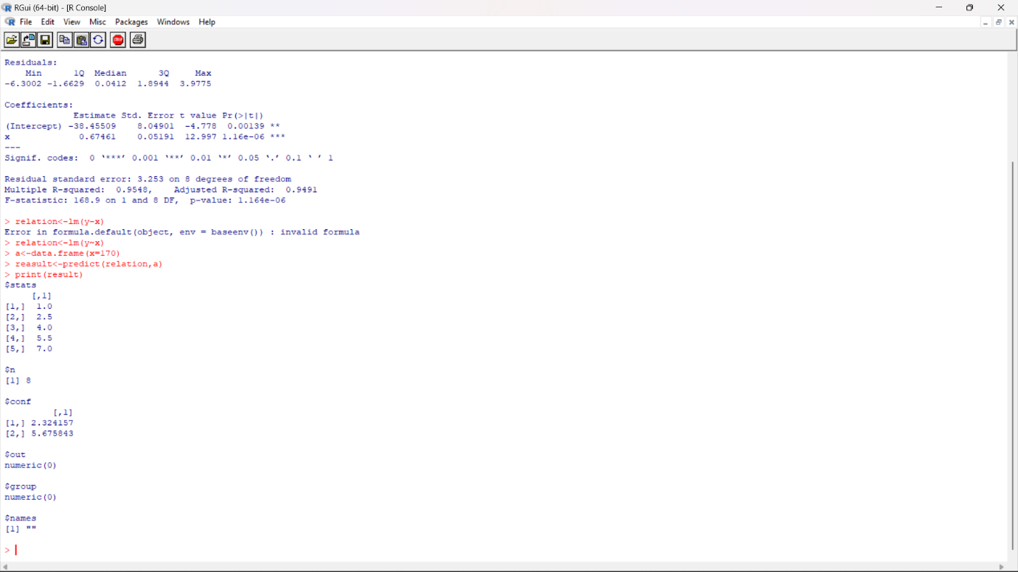**2.PREDICTION ANALYSIS USING LINEAR REGERSSION.**

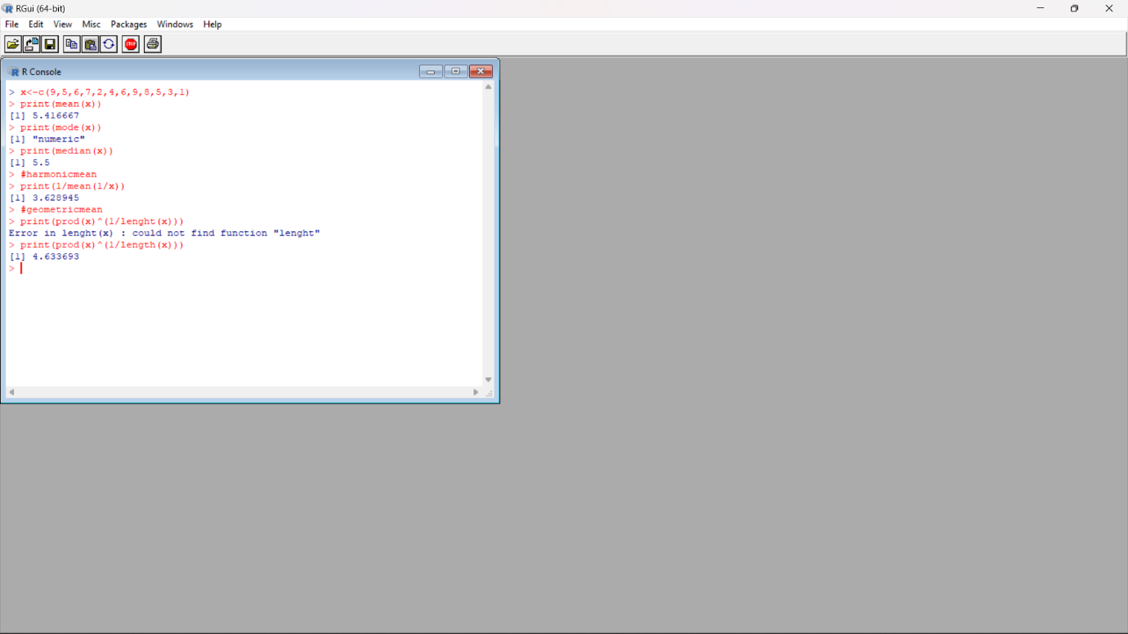**4.CENTRAL TENDENCY USING R-TOOL?**

**5.NORMALIZATION?**

